European Rural Network
Sustainability Plan
SURF Project

Project document
29.07.2025
Authors
ARCES (IT)

Table of content
Introduction 3
The goals of the Sustainability Plan 3
Methodology 4
Network Benefits for Members 5

Introduction
The European Rural Network (ERN) is a lasting platform that unites organisations and individuals working to support and promote rural development across Europe.
The network aims to improve the quality of life for people living in rural areas by improving educational offerings and promoting sustainable development and climate change adaptation. The network also serves as a space for exchange of ideas and best practices among its members and they will have direct access to knowledge on climate change and the PAR approach.
Ensuring its long-term sustainability is crucial for maintaining and expanding its role as a collaborative hub for innovation, policy exchange, and practical action in rural areas.
The network brings together a broad and diverse range of stakeholders, including local and regional authorities, public administration professionals, non-governmental organisations, foundations, and companies engaged in rural development. This diversity not only enriches the dialogue within the network but also ensures that its activities are grounded in the realities of rural communities across different contexts.
Currently, the ERN includes 50 members from both the public and private sectors, located in the countries involved in the project. Its growing membership highlights the need for a transnational platform that fosters cooperation, amplifies local successes, and addresses common challenges in rural regions.

The goals of the Sustainability Plan
The creation of the European Rural Network (ERN) stands as one of the main achievements of the project. In order to ensure the continuity and long-term vitality of this network, ARCES, together with its partners, has developed a dedicated Sustainability Plan.
This plan outlines a strategic framework aimed at preserving, expanding, and promoting the ERN in the coming years. Its core objective is to grow a dynamic and collaborative network of individuals, organisations, and institutions that actively share good practices focused on mitigating the impacts of climate change in rural areas.
Through continued collaboration, knowledge exchange, and engagement with new and existing stakeholders, the ERN aspires to remain a long-lasting platform for supporting sustainable development in rural communities across Europe.

Methodology
To ensure the long-term sustainability of the ERN, the project partners believe that communication and awareness raising actions are very important. To this end they have identified practical tools and approaches that can support the ongoing growth and relevance of the network beyond the project’s official timeframe. The partners commit themselves to promote the network through several actions:
- The maintenance of the Project website after the funding ends.
- Dissemination of the Membership Invitation letter, available on the official project website, to encourage new members to join the ERN.
- Creation of a dedicated LinkedIn Group to share events, ideas, and best practices related to rural development and climate change mitigation across different territories. This group offers a space for continuous exchange and collaboration among network members remaining active after the end of the project.
- Dissemination and enrichment of the Interactive SURF Online Map that shows case studies from different parts of Europe. This map acts as both a repository of inspiring local mitigation strategies and an incentive for new stakeholders to join the network. New members are encouraged to contribute their own examples of climate resilience and sustainable practices, enriching the map and fostering greater awareness and knowledge-sharing across Europe.
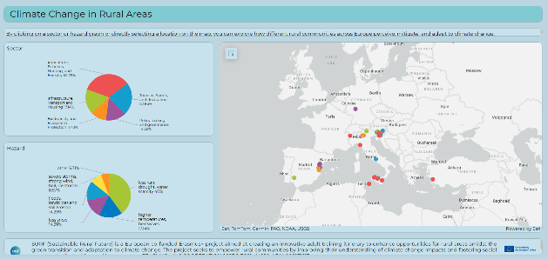
- Create a section for the ERN on each partner's institutional project website to enhance the visibility and outreach of the ERN.
6. Sign the Palermo Declaration, a document issued in Palermo during the final project closing event on October 28, 2025. Its purpose is to promote the ERN and attract new members attending the event.

These activities are designed not only to support ongoing engagement but also to reinforce the ERN as a living, evolving platform for innovation and collaboration in rural sustainability.

Network Benefits for Members
To encourage continued participation, it is essential to clearly communicate the value of being part of the SURF network. Both individuals and organizations will benefit from:
- Access to high-quality resources: Ongoing access to SURF’s training materials, methodologies, case studies, and toolkits developed during the project.
- Visibility and recognition: Opportunities to showcase activities, share best practices, and be featured in SURF-related dissemination efforts.
- Collaboration opportunities: Invitations to participate in future projects, research, and policy initiatives promoted by the network or its members.
- Peer exchange and knowledge sharing: Participation in thematic discussions, webinars, and online forums where members can exchange experiences, challenges, and solutions.
- Professional development: Learning opportunities through continued engagement with experts, access to resources, and participation in joint events or training.

